1. 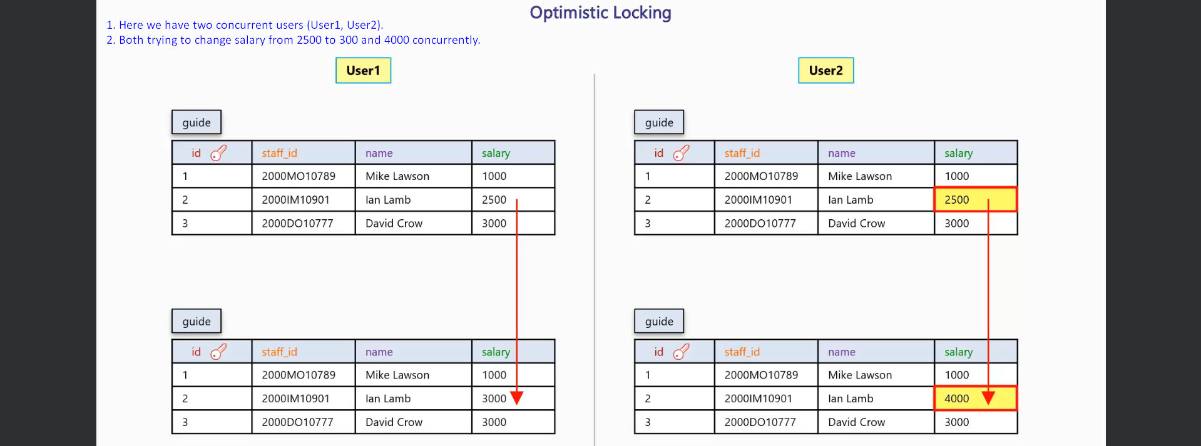
2. 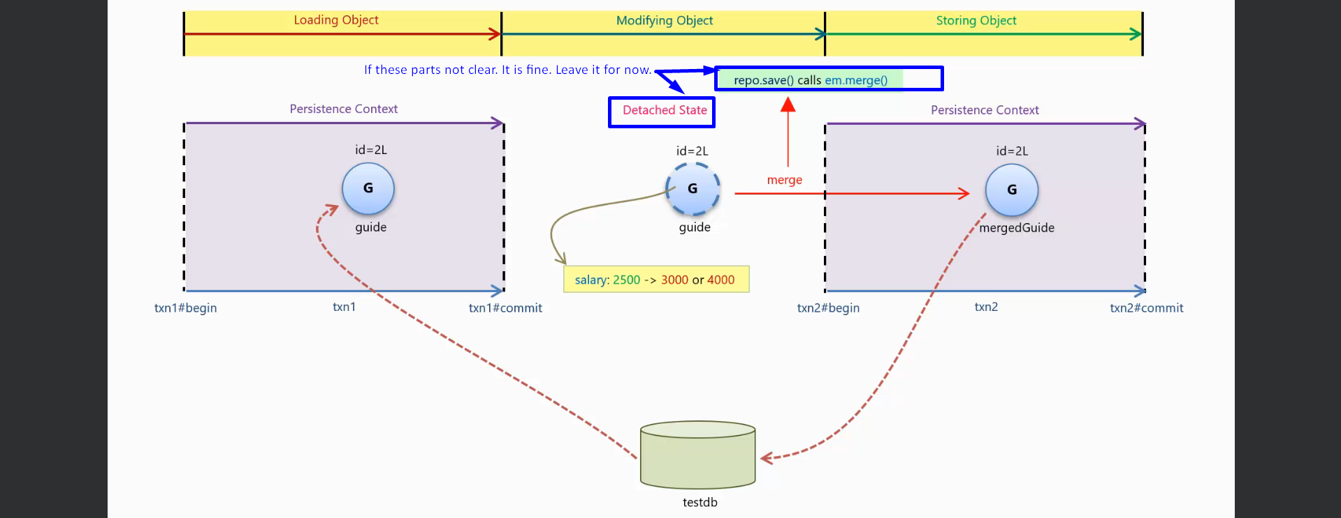
3. 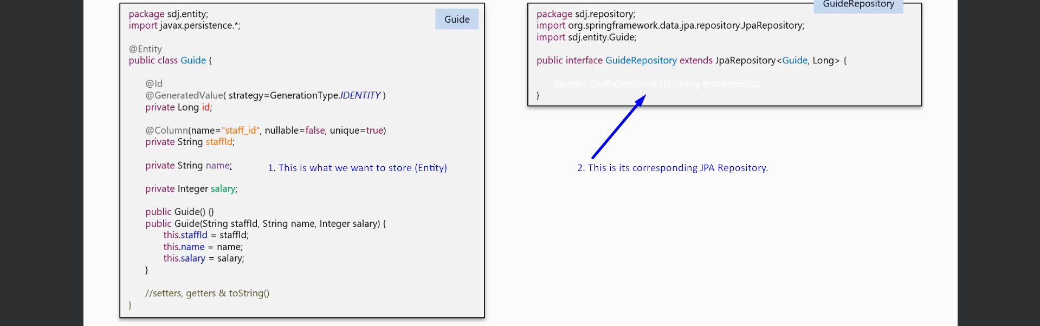
4. 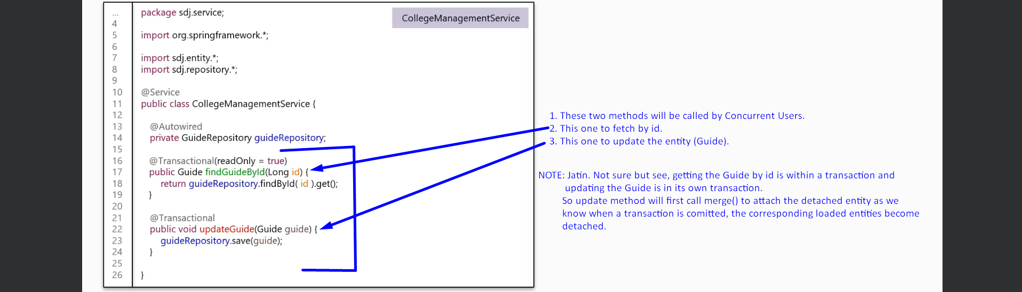
5. 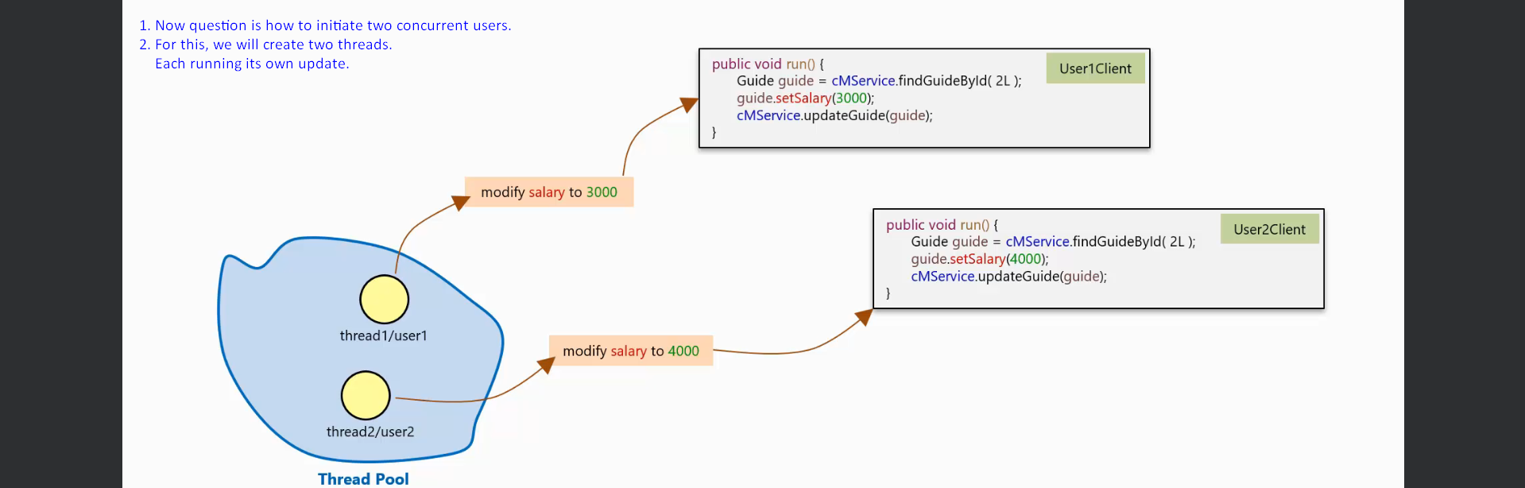
6. 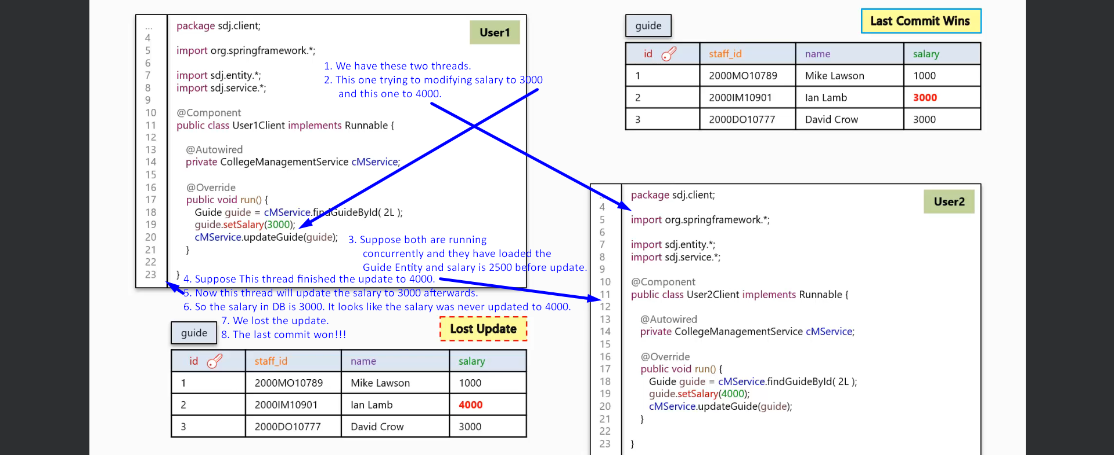
7. How do we prevent our app from having lost update?  
   Well, we tell user1 about the update made by user2 by displaying a message to him before user1 could persist its modifications.  
   We do that by the Strategy called Versioning.
8. How do we do versioning?
9. By introducing a new column named “version” that is updated every time, Guide entity is updated.  
   Hibernate automatically update the version number of the row whenever we update a row.
10. 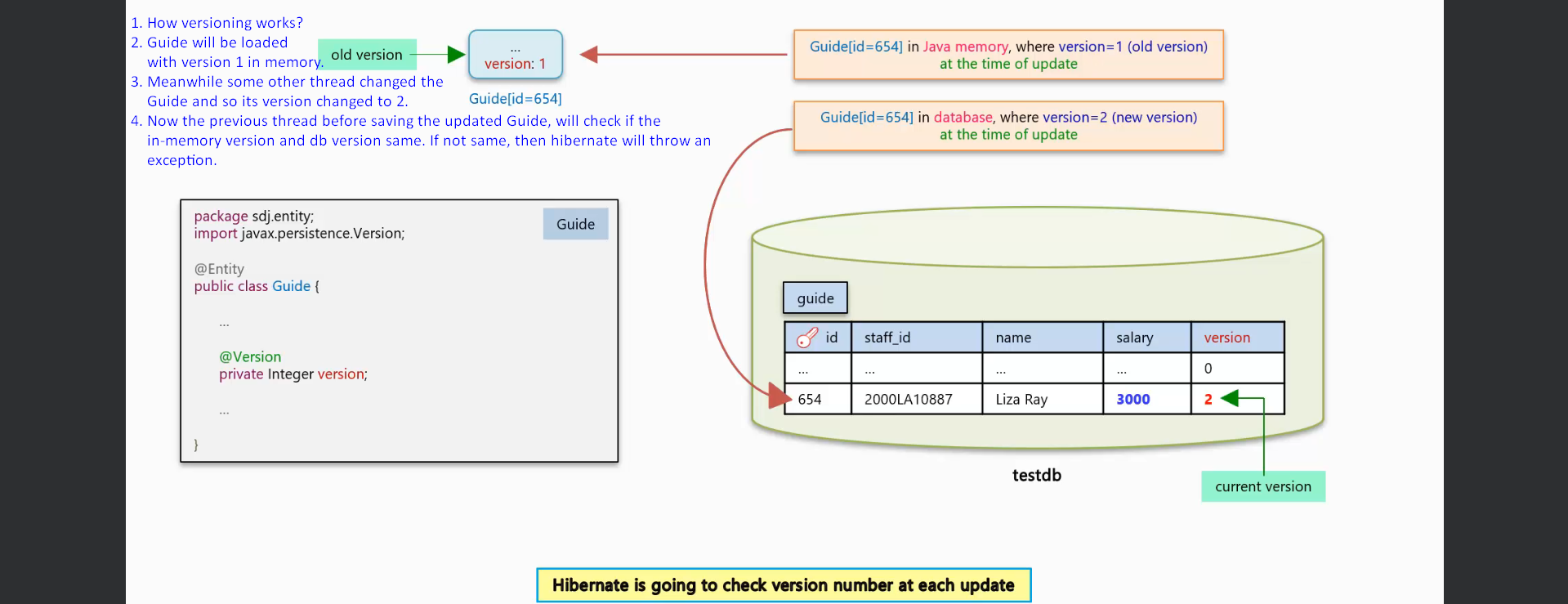
11. 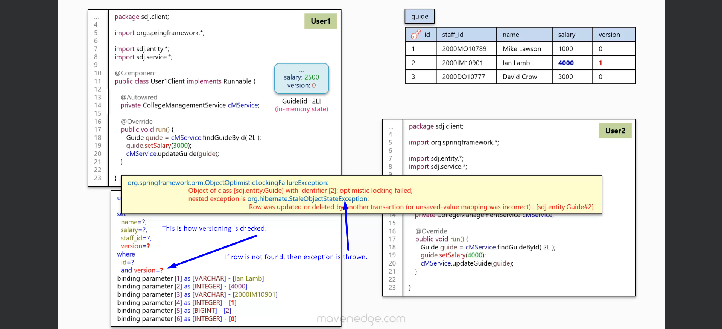
12. 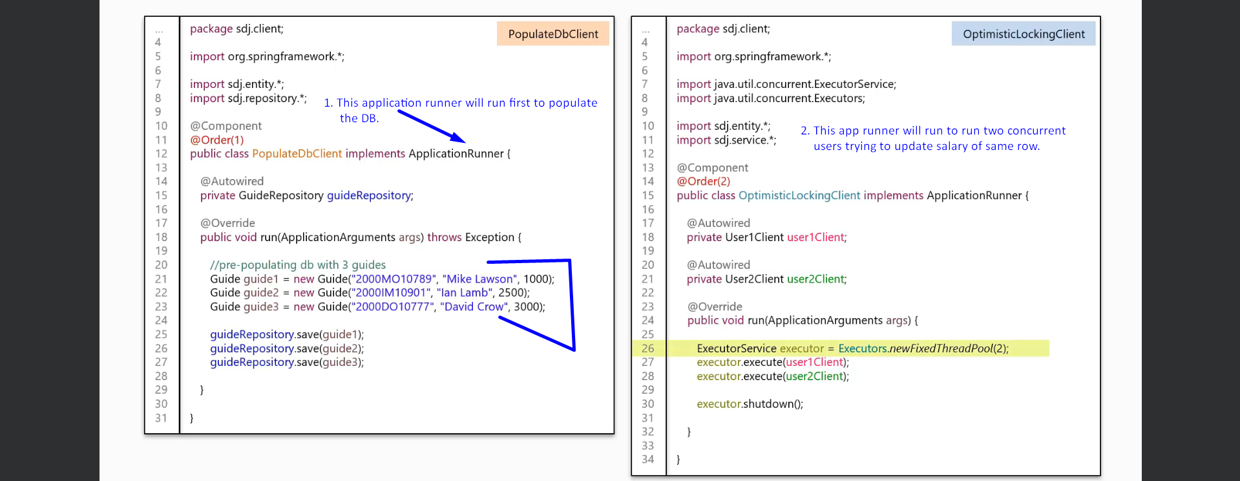
13. 